TRAIN TEST AND SAVE MODEL

|  |  |
| --- | --- |
| **Date** | 16 November 2022 |
| **Team ID** | PNT2022TMID33575 |
| **Project** | Natural Disasters Intensity Analysis And Classification Using Artificial Intelligence |

**TRAIN TEST AND SAVE MODEL:**

* In this tutorial, you will learn how to automatically detect natural disasters (earthquakes, floods, wildfires, cyclones/hurricanes) with up to 95% accuracy using Keras, Computer Vision, and Deep Learning.
* I remember the first time I ever experienced a natural disaster — I was just a kid in kindergarten, no more than 6-7 years old. We were outside for recess, playing in the jungle gym, running around like the wild animals that young children are. Rain was in the forecast. It was cloudy.
* And very humid. My mother had given me a coat to wear outside, but I was hot and uncomfortable — the humidity made the cotton/polyester blend stick to my skin. The coat, just like the air around me, was suffocating.

# All of a sudden the sky changed from “normal rain clouds” to anominous green:

➤ The recess monitor reached into her pocket, grabbed her whistle, and blew it, indicating it was time for us to settle our wild animal antics and come inside for schooling

➤ After recess we would typically sit in a circle around the teacher’s desk for show-and-tell.

➤ But not this time.

# We were immediately rushed into the hallway and were told to cover our heads with our hands — a tornado had just touched down near our school.

➤ Just the thought of a tornado is enough to scare a kid. But to actually experience one? That’s something else entirely.

➤ The wind picked up dramatically, an angry tempest howling and berating our school with tree branches, rocks, and whatever loose debris was not tied down.

➤ It’s interesting how experiences as a young kid, especially the ones that scare you, shape you and mold you after you grow up. A few days after the event my mom took me to the local library.

I picked out every book on tornadoes and hurricanes that I could find. Even though I only had a basic reading level at the time, I devoured them, studying the pictures intently until I could recreate them in my mind — imagining what it would be like to be inside one of those storms. Later, in graduate school, I experienced the historic 2012 derecho that delivered 60+ MPHsustained winds and gusts of over 100 MPH, knocking down power lines and toppling large trees

➤ That storm killed 29 people, injured hundreds of others, and caused loss of electricity and power in parts of the United States east coast for over 6 days, an unprecedented amount of time in the modern-day United States.

Natural disasters cannot be prevented — but they can be detected, giving people precious time to get to safety.

To learn how to detect natural disasters with Keras, Computer Vision, and Deep Learning, just keepreading!

**To learn how to detect natural disasters with Keras, Computer Vision, and Deep Learning, just keepreading!**

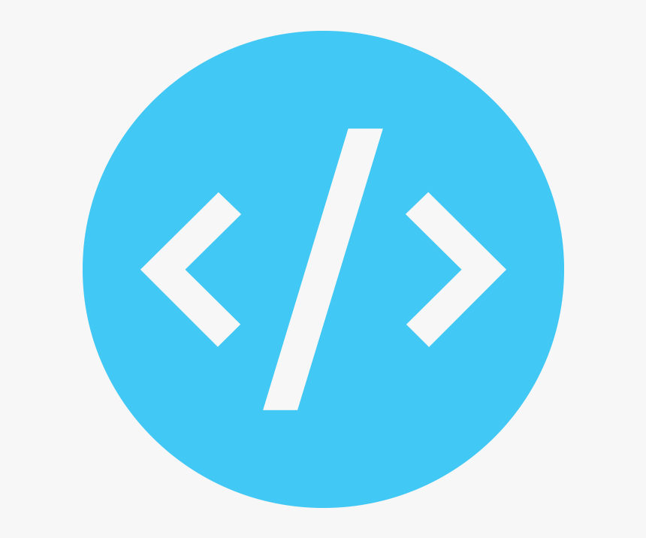

Looking for the source code to this post?

# JUMP RIGHT TO THE DOWNLOADS SECTION

Detecting Natural Disasters with Keras and Deep Learning In the first part of this tutorial, we’ll discuss how computer vision and deep learning algorithms can be used to automatically detect natural disasters in images and video streams.

From there we’ll review our natural disaster dataset which consists of four classes:

➤ Cyclone/hurricane

➤ Earthquake

➤ Flood

➤ Wildfire

We’ll then design a set of experiments that will:

➤ Help us fine-tune VGG16 (pre-trained on ImageNet) on our dataset.

➤ Find optimal learning rates.

➤ Train our model and obtain > 95% accuracy! Let’s get started! How can computer vision and deep learning detect natural disasters?

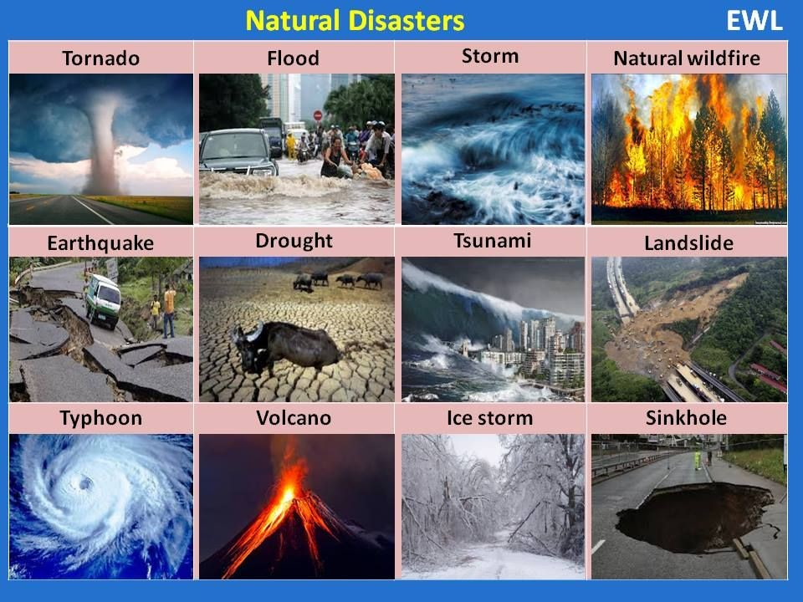

Figure 1: We can detect natural disasters with Keras and Deep Learning using a data set of natural disaster images. (image source)

Natural disasters cannot be prevented — but they can be detected All around the world we use sensors to monitor for natural disasters:

➤ Seismic sensors (seismometers) and vibration sensors (seismoscopes) are used to monitor earthquakes (and downstream tsunamis).

➤ Radar maps are used to detect the signature “hook echo” of a tornado (i.e., a hook that extends from the radar echo).

➤ Flood sensors are used to measure moisture levels while water level sensors monitor the height of water along a river, stream, etc.

➤ Wildfire sensors are still in their infancy but hopefully will be able to detect trace amounts of smoke and fire.

**Each of these sensors is highly specialized to the task at hand** — detect a natural disaster early, alert people, and allow them to get to safety.

➤ Using computer vision we can augment existing sensors, thereby increasing the accuracy of natural disaster detectors, and most importantly, allow people to take precautions, stay safe, and prevent/reduce the number of deaths and injuries that happen due to these disasters.